Staples.com Marketplace
Where to open the marketplace: category-level recommendations
Which categories to open to marketplace sellers, which to keep in 1P, which to fix, and which to pass
Prepared for: Pat, Staples · Scope: category level (L1–L3); product archetypes are a separate PoC · Date: 24 September 2026
Evidence base: the navigation trees of Staples and five competitors – Office Depot, West Elm, Wayfair, Amazon and Walmart. That covers 13,306 competitor category pages, matched to Staples by two independent methods and checked against 914 labelled examples. Every chart and number in this document is produced by the delivered Python code and can be traced to Category_Recommendations_v2.xlsx.

1. The answer on one page
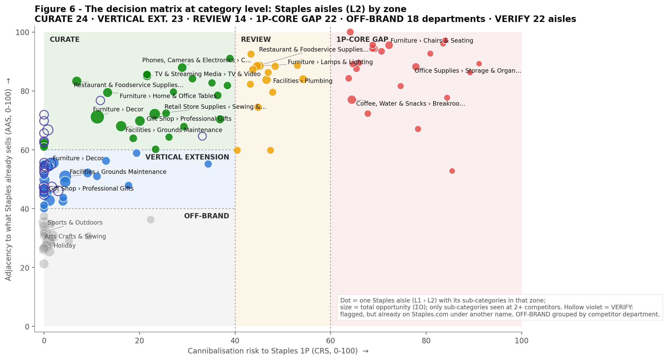
Figure 6 – The decision matrix at category level. Each dot is a Staples aisle (L1 › L2) holding the sub-categories that fall in that zone; dot size = total opportunity. Source: run_framework.py → figures/fig06_matrix_aisles.png · sheet Aisle_Recommendations

Five calls for Staples
- Open now to curated marketplace sellers (CURATE) – 24 aisles, 48 sub-categories. Lead with Furniture › Décor: bedding, bath and shower accessories, candles, décor accents, vanities and daybeds. Four of the five competitors carry far more here. Staples has 8 items on its Bath & Shower Accessories shelf; West Elm alone has 20x that, scaled to catalogue size. Next come Sewing & Tailoring (quilting, sewing machines, garment steamers), Grounds Maintenance (outdoor planters, hedge trimmers, parts), Commercial Restaurant Equipment (home brewing, food trailers) and Home & Office Tables (buffets and sideboards, kids' tables).
- Enter in phase 2, through a vertical Staples already serves (VERTICAL EXTENSION) – 23 aisles, 53 sub-categories. This covers garden and greenhouse equipment, outdoor structures (gazebo canopies, railings, shutters), bedroom furniture (armoires, teen dressers, nightstands), vases and picnic ware, fitness and sports equipment, and material handling. Each is a real gap, but it sits one step away from Staples' current neighbourhood, so it needs an anchor audience: education, hospitality or facilities.
- Keep in 1P and fix the assortment there (1P-CORE GAP) – 22 aisles, 30 sub-categories. Competitors are deeper in office chairs, breakroom appliances, storage and organisation, chair mats, partitions, file cabinets, binders and coffee. These are Staples' own core lines, and a marketplace there would compete with Staples' own shelf. 14 more aisles, including lighting, tabletop, bath mats and towels, and bookcases, sit in REVIEW for a merchant decision.
- Fix findability before buying assortment (VERIFY) – 22 aisles, 31 sub-categories. In the verification check, 121 of the 219 categories the models first flagged as "missing" turned out to be already on Staples.com under other names. Examples are candles and home fragrance, evaporative coolers, pull-out pantries, sneeze guards and camera lenses. Customers who search competitor vocabulary may not find them.
- Pass (OFF-BRAND) – 16 competitor departments (plus 2 Staples aisles), 57 sub-categories. These are real gaps in the wrong store for Staples: livestock and garden supplies, craft niches such as screen printing, purse making and embroidery, sports equipment such as swimming and handball, and holiday-specific décor.

Where the opportunity is, by theme (Figure 14): Home décor & furnishings leads: it has the most CURATE sub-categories (14) and the highest summed opportunity across CURATE and VERTICAL EXTENSION (13.9). Celebrations, gifting & creativity (11.6) and Outdoor living & grounds (11.9) follow. This is the "white chair" logic in data: design and lifestyle versions of things Staples already sells to the same customer, at low risk to its 1P core.
How sure are we? Zone placements are stable: 10 of the top 20 CURATE sub-categories stay CURATE in at least 80% of 500 stress-test runs. The exact ranking inside the zone is less stable, so treat the top of each list as a shortlist, not a fixed order. Every recommendation also carries an evidence grade: A means 3 or more competitors and both methods agree.

2. What the five competitors tell us
Each competitor plays a different role in the evidence. The same method is applied to all of them, and it adapts to what each navigation tree provides. Office Depot and West Elm publish item counts, so depth can be measured in items. Walmart publishes counts only at the top two levels. Wayfair and Amazon publish none, so for them we measure breadth: how many distinct shelves a competitor devotes to a category.
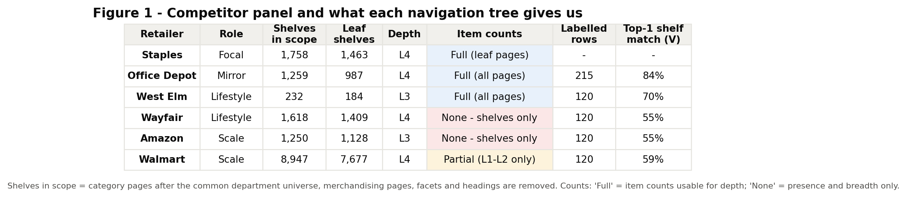
Figure 1 – The competitor panel and what each navigation tree gives us. Source: run_framework.py → figures/fig01_data_availability.png · sheet Data_Audit
- Office Depot is a mirror. 98% of its shelves, drawn at random, already exist at Staples. It tells us where Staples is shallower in its own core (the 1P-CORE GAP list), but it offers almost no whitespace.
- West Elm and Wayfair are the lifestyle lens. 11% of West Elm's shelves and 18% of Wayfair's are missing at Staples. The bigger story is depth: where Staples does have the shelf, it is often a token one. Bath & Shower Accessories has 8 items and Curtains, Blinds & Shades has 2.
- Amazon and Walmart are the scale lens. 21% of Amazon's and 13% of Walmart's in-scope shelves are missing at Staples. Their breadth confirms which lifestyle gaps are mainstream demand rather than one retailer's taste.
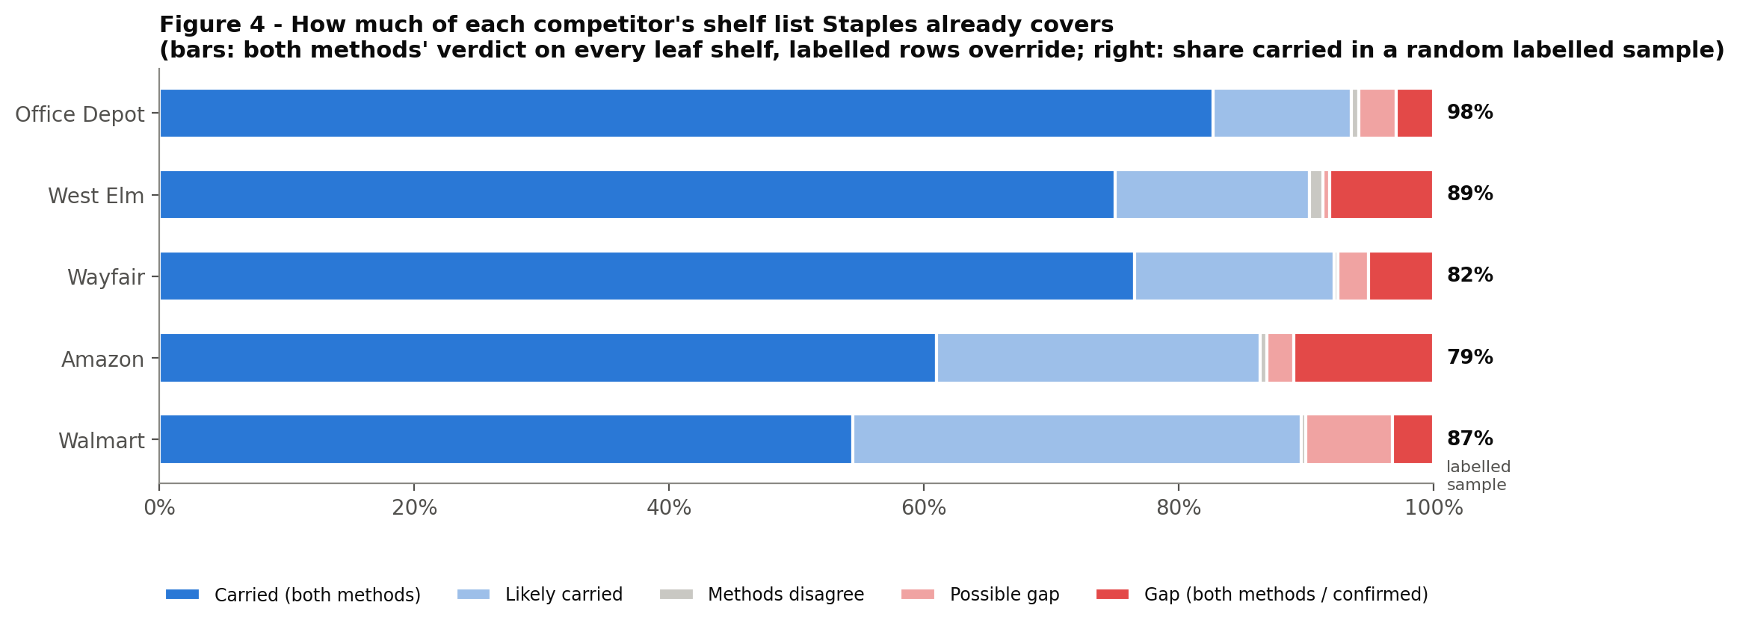
Figure 4 – How much of each competitor's shelf list Staples already covers. Source: run_framework.py → figures/fig04_staples_coverage.png · sheets Node_Ensemble, Calibration

3. How to read the matrix
Think of Staples.com as a store map. For every category a competitor sells, we ask three questions. Is it missing at Staples, or too thin? Is it close to what Staples already sells – the adjacency score, AAS? Would a marketplace there take sales from Staples' own 1P shelf – the cannibalisation risk score, CRS? The two scores place every category in one of six zones.
Zone | Rule | What it means for Staples | Action
CURATE | CRS < 40 and AAS ≥ 60 | A gap right next to what Staples sells, with little 1P at stake | Open to curated marketplace sellers now
VERTICAL EXTENSION | CRS < 40 and AAS 40–60 | A real gap one step further out | Phase 2: enter through a vertical Staples serves (education, hospitality, facilities)
REVIEW | CRS 40–60 | Sits next to a 1P line; could go either way | Merchant decision with sales and margin data
1P-CORE GAP | CRS ≥ 60 | Competitors are deeper in a Staples core line | Fix in 1P merchandising; keep out of the marketplace
OFF-BRAND | CRS < 40 and AAS < 40 | A real gap, far from Staples' customers | Pass
VERIFY | Flagged as missing, but may exist under another name | Often a findability problem, not an assortment gap | Check first; fix naming and navigation

Two kinds of recommendation. "New" means the category does not exist at Staples (ENTER). "Deepen" means Staples has the aisle, but at least two competitors carry at least twice as much of it, relative to their size (DEEPEN). Recommendations are shown at the level Staples would act on: a Staples aisle (L1 › L2), with the sub-categories (L2–L3) to add underneath it. Only sub-categories seen at two or more competitors drive an aisle-level call. The 322 single-competitor sub-categories are kept as a watch list in the workbook.

The scores behind every recommendation
Score | Plain-language meaning | How it is built (both methods averaged)
AAS – adjacency (0–100) | How embedded the category is in what Staples already sells. 100 = as embedded as a typical Staples shelf | Vector method: closeness to the 10 nearest Staples shelves. Graph method: network proximity to Staples' assortment, plus how much of the competitor's aisle Staples already carries
CRS – cannibalisation risk (0–100) | How much 1P revenue a marketplace here would put at risk | Closeness to a Staples shelf × how core that shelf is to 1P (office supplies, paper and ink score high; décor and lifestyle score low)
PC – peer consensus | How many of the five competitors show the gap | Share of competitors that carry the category (new) or are at least 2x deeper (deepen)
GS – gap size | How big the missing assortment is | Percentile of the missing chunk within each competitor's catalogue: shelves everywhere, plus items where counts exist
O – opportunity (0–1) | The ranking inside a zone | O = (0.35 PC + 0.35 GS + 0.30 AAS/100) × (1 − CRS/100)
Grade A / B / C | Strength of evidence | A = 3+ competitors and both methods agree on the zone; B = 2+ competitors or the methods agree; C = neither

4. CURATE – open these to marketplace sellers now
Decision: curate a marketplace assortment in these aisles. Each is next to what Staples already sells, and Staples' own 1P revenue there is small.
24 aisles · 48 sub-categories seen at 2+ competitors · median AAS 73, median CRS 23

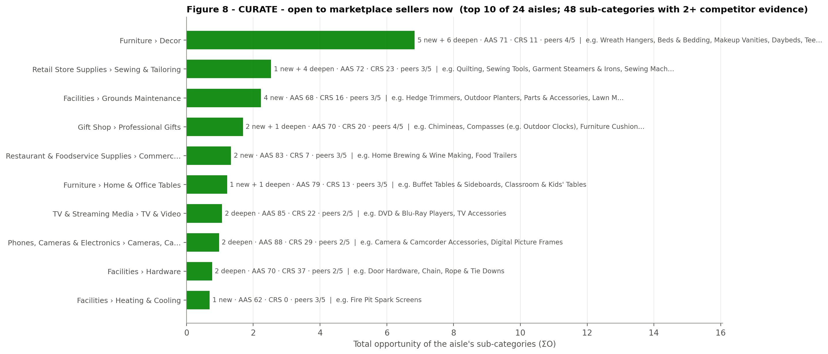
Figure 8 – CURATE aisles ranked by total opportunity, with the sub-categories behind each. Source: run_framework.py → figures/fig08_zone_curate.png · sheet CURATE, Aisle_Recommendations
# | Staples aisle (L1 › L2) | Sub-categories to add or deepen (L2–L3) | Peers (best sub-category) | All competitors showing gaps in this aisle | AAS | CRS | ΣO | Grade
1 | Furniture › Decor | Wreath Hangers; Beds & Bedding; Makeup Vanities; Daybeds; Teen Tapestries and Wall Hangings (+6 more) | 4/5 | Amazon, Walmart, Wayfair, West Elm | 71 | 11 | 6.83 | A
2 | Retail Store Supplies › Sewing & Tailoring | Quilting; Sewing Tools; Garment Steamers & Irons; Sewing Machines; Fabric | 3/5 | Amazon, Office Depot, Walmart | 72 | 23 | 2.53 | A
3 | Facilities › Grounds Maintenance | Hedge Trimmers; Outdoor Planters; Parts & Accessories; Lawn Mowers & Tractors | 3/5 | Amazon, Walmart, Wayfair, West Elm | 68 | 16 | 2.23 | A
4 | Gift Shop › Professional Gifts | Chimineas; Compasses (e.g. Outdoor Clocks); Furniture Cushion & Cushion Covers | 4/5 | Amazon, Walmart, Wayfair, West Elm | 70 | 20 | 1.69 | A
5 | Restaurant & Foodservice Supplies › Commercial Restaurant Equipment | Home Brewing & Wine Making; Food Trailers | 3/5 | Amazon, Walmart, Wayfair | 83 | 7 | 1.33 | A
6 | Furniture › Home & Office Tables | Buffet Tables & Sideboards; Classroom & Kids' Tables | 3/5 | Walmart, Wayfair, West Elm | 79 | 13 | 1.22 | A
7 | TV & Streaming Media › TV & Video | DVD & Blu-Ray Players; TV Accessories | 2/5 | Amazon, Office Depot, Walmart | 85 | 22 | 1.06 | B
8 | Phones, Cameras & Electronics › Cameras, Camcorders & Accessories | Camera & Camcorder Accessories; Digital Picture Frames | 2/5 | Amazon, Office Depot, Walmart | 88 | 29 | 0.98 | B
9 | Facilities › Hardware | Door Hardware; Chain, Rope & Tie Downs | 2/5 | Amazon, Office Depot, Walmart | 70 | 37 | 0.77 | B
10 | Facilities › Heating & Cooling | Fire Pit Spark Screens | 3/5 | Amazon, Walmart, Wayfair | 62 | 0 | 0.69 | B

What this means for Staples
- Make Furniture › Décor the flagship curated aisle. Staples already has the aisle, but most of its sub-shelves are token. Beds & Bedding: Staples 299 items; Wayfair 10.3x (88 shelves), Walmart 7.4x (176 shelves), West Elm 4.4x (1,030 items). Bath & Shower Accessories: Staples 8 items; West Elm 20.1x (144 items), Wayfair 3.1x (6 shelves), Walmart 2.9x (13 shelves). Candles: Staples 25 items; West Elm 21.3x (433 items), Walmart 3.3x (15 shelves). Shower Curtains: Staples 6 items; West Elm 11.2x (62 items), Wayfair 5.3x (11 shelves), Walmart 4.5x (21 shelves). New shelves competitors carry and Staples does not: makeup vanities, daybeds, wreath hangers, teen tapestries and wall hangings.
- Sewing & Tailoring is a surprise candidate with strong evidence (Amazon, Office Depot, Walmart). Quilting, sewing tools, garment steamers and irons, and sewing machines extend Staples' Retail Store Supplies › Sewing & Tailoring aisle to a home-crafting customer.
- Outdoor living: outdoor planters, hedge trimmers and outdoor tool parts extend Facilities › Grounds Maintenance. Staples files its patio and outdoor shelves under Gift Shop › Professional Gifts › "Compasses" – 1,116 patio-furniture items sit on that path (Staples 1,276 items; Wayfair 3.5x (51 shelves), Walmart 2.8x (119 shelves), Amazon 2.6x (20 shelves)). That label hides the category from shoppers, so rename it when opening it to sellers.
- Home & hospitality furniture: buffet tables and sideboards (Walmart, Wayfair, West Elm) and classroom and kids' tables extend Furniture › Home & Office Tables. Home brewing and food trailers extend Commercial Restaurant Equipment.
- Technology accessories with low core risk: camera and camcorder accessories, digital picture frames, TV accessories, DVD and Blu-ray players, and cell phones, where Office Depot and Walmart are several times deeper.

The peer and depth evidence behind the top picks
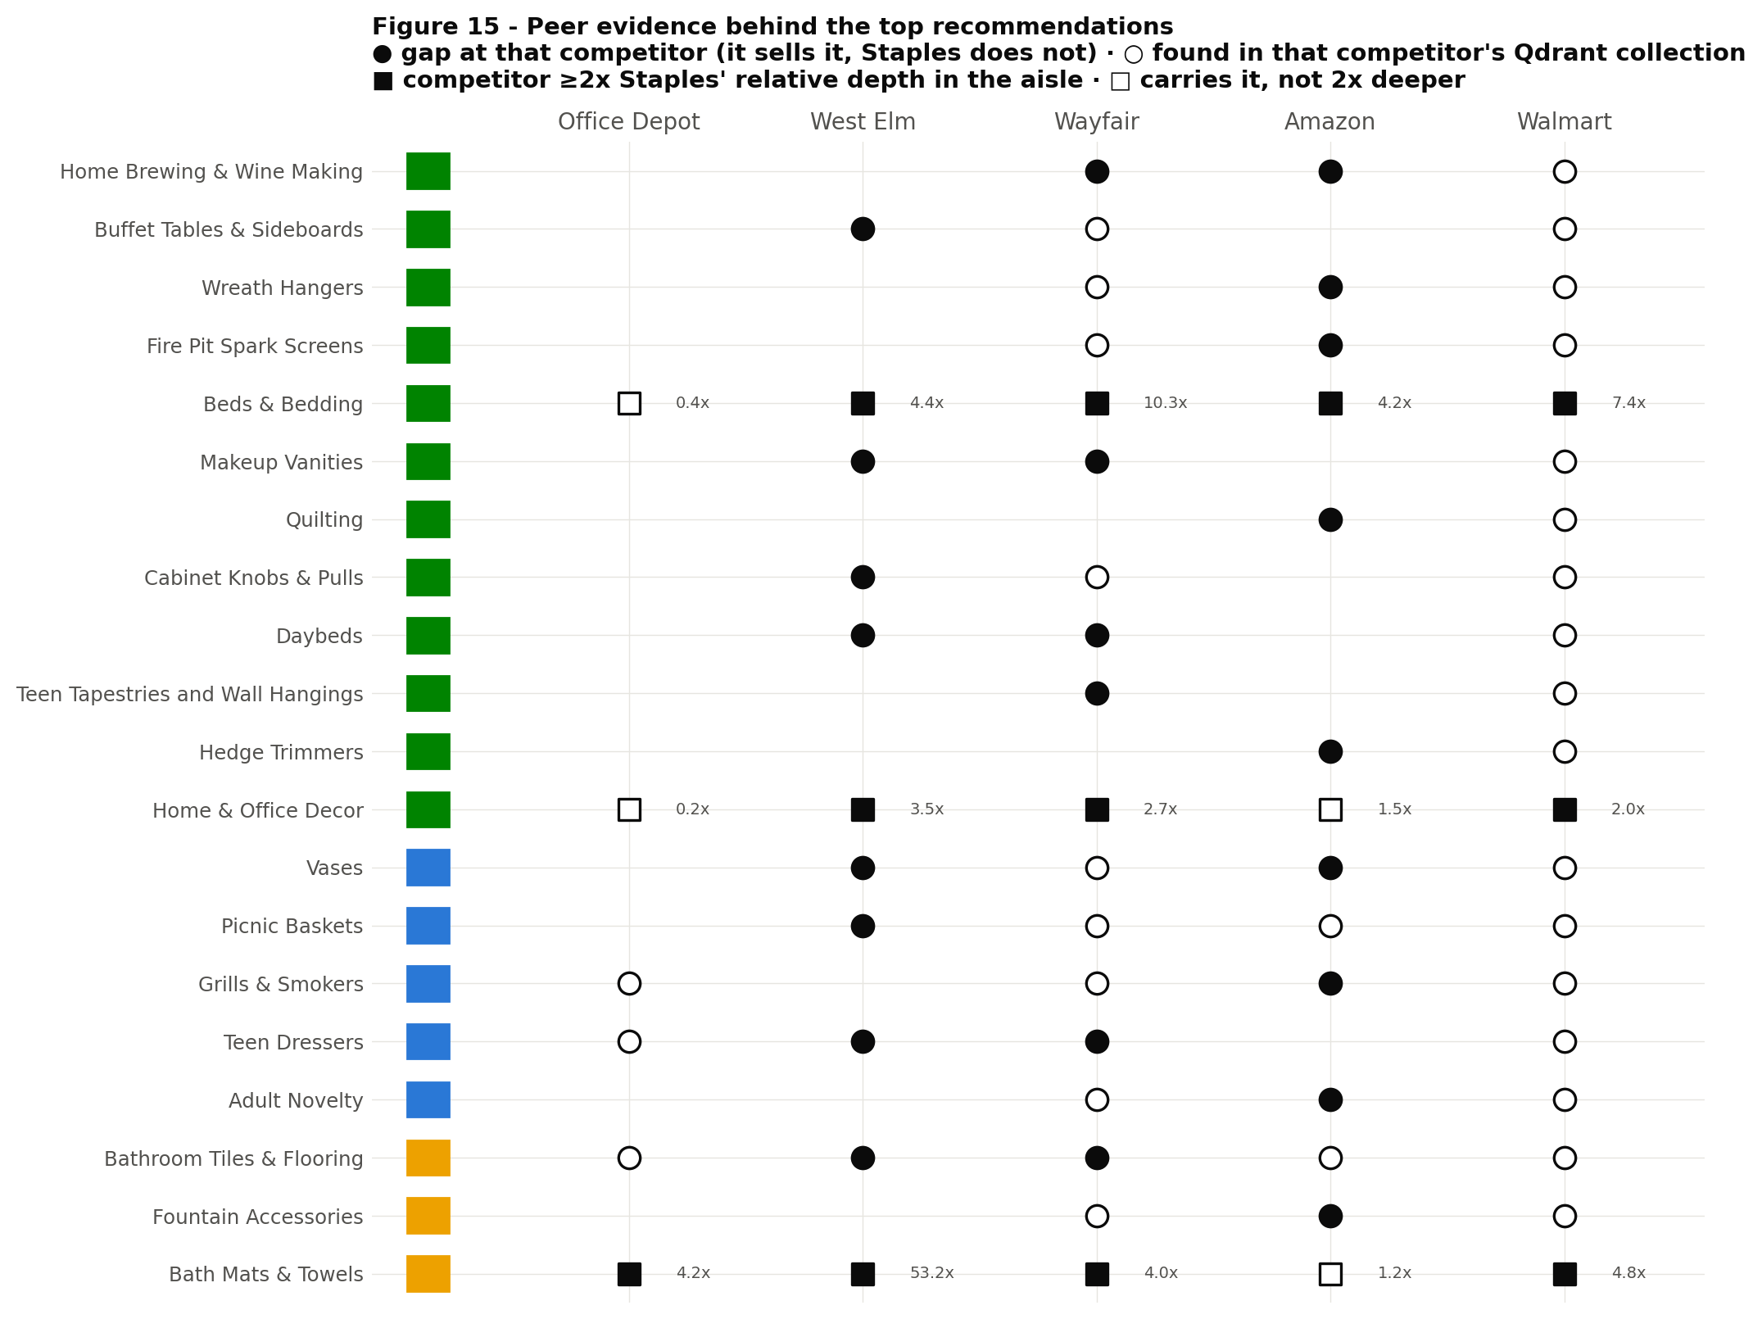
Figure 15 – Peer evidence behind the top recommendations: which competitors carry each gap (circles) or are at least 2x deeper (squares). Source: run_framework.py → figures/fig15_peer_consensus.png · sheets Concept_Members, Deepen_Evidence
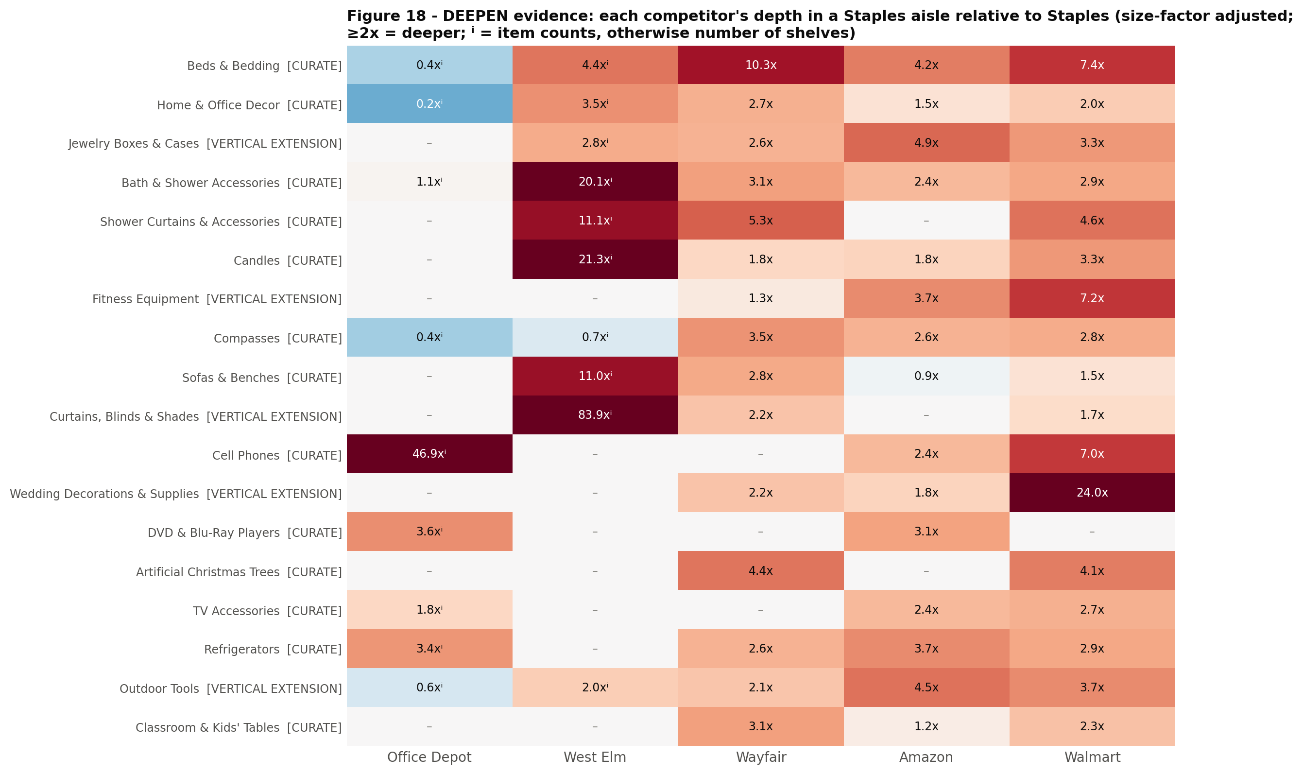
Figure 18 – DEEPEN evidence: each competitor's depth in a Staples aisle relative to Staples (size-factor adjusted; ⁱ = item counts). Source: run_framework.py → figures/fig18_deepen_evidence.png · sheet Deepen_Evidence

5. VERTICAL EXTENSION – phase 2, through a vertical Staples already serves
Decision: do not open these to general marketplace traffic yet. Enter them through an audience Staples already serves – education, hospitality, facilities or home office – once the CURATE aisles prove the seller model.
23 aisles · 53 sub-categories · median AAS 49, median CRS 0

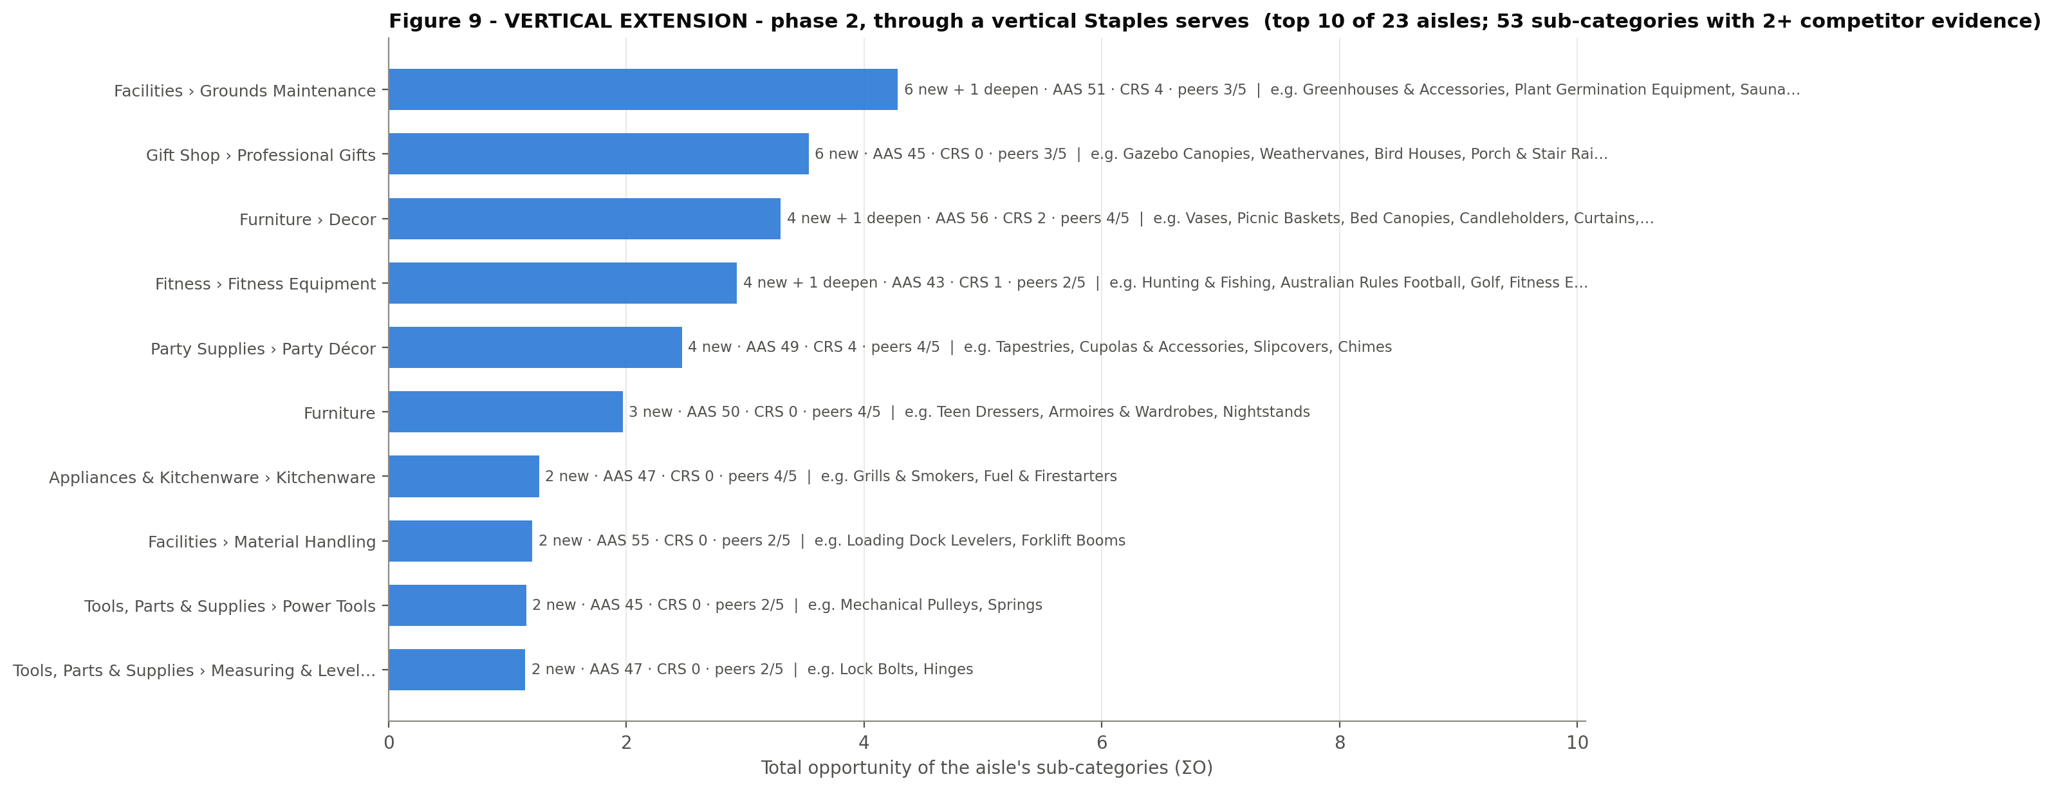
Figure 9 – VERTICAL EXTENSION aisles ranked by total opportunity. Source: run_framework.py → figures/fig09_zone_vertical_extension.png · sheet VERTICAL_EXTENSION
# | Staples aisle (L1 › L2) | Sub-categories to add or deepen (L2–L3) | Peers (best sub-category) | All competitors showing gaps in this aisle | AAS | CRS | ΣO | Grade
1 | Facilities › Grounds Maintenance | Greenhouses & Accessories; Plant Germination Equipment; Saunas; Plant & Soil Monitoring; Tillers (+2 more) | 3/5 | Amazon, Walmart, Wayfair | 51 | 4 | 4.28 | A
2 | Gift Shop › Professional Gifts | Gazebo Canopies; Weathervanes; Bird Houses; Porch & Stair Railings; Shutters (+1 more) | 3/5 | Amazon, Walmart, Wayfair | 45 | 0 | 3.53 | B
3 | Furniture › Decor | Vases; Picnic Baskets; Bed Canopies; Candleholders; Curtains, Blinds & Shades | 4/5 | Amazon, Walmart, Wayfair, West Elm | 56 | 2 | 3.30 | A
4 | Fitness › Fitness Equipment | Hunting & Fishing; Australian Rules Football; Golf; Fitness Equipment; Boating & Sailing | 2/5 | Amazon, Walmart | 43 | 1 | 2.93 | B
5 | Party Supplies › Party Décor | Tapestries; Cupolas & Accessories; Slipcovers; Chimes | 4/5 | Amazon, Walmart, Wayfair, West Elm | 49 | 4 | 2.47 | B
6 | Furniture | Teen Dressers; Armoires & Wardrobes; Nightstands | 4/5 | Office Depot, Walmart, Wayfair, West Elm | 50 | 0 | 1.97 | A
7 | Appliances & Kitchenware › Kitchenware | Grills & Smokers; Fuel & Firestarters | 4/5 | Amazon, Office Depot, Walmart, Wayfair | 47 | 0 | 1.26 | B
8 | Facilities › Material Handling | Loading Dock Levelers; Forklift Booms | 2/5 | Amazon, Walmart | 55 | 0 | 1.21 | B
9 | Tools, Parts & Supplies › Power Tools | Mechanical Pulleys; Springs | 2/5 | Amazon, Walmart, Wayfair | 45 | 0 | 1.16 | B
10 | Tools, Parts & Supplies › Measuring & Leveling Tools | Lock Bolts; Hinges | 2/5 | Amazon, Walmart | 47 | 0 | 1.15 | B

What this means for Staples
- Garden, grounds and outdoor structures – greenhouses, plant germination, soil monitoring and tillers extend Facilities › Grounds Maintenance; gazebo canopies, weathervanes, bird houses, porch railings and shutters sit next to Staples' patio shelves. Enter through facilities and hospitality buyers before consumers.
- Bedroom and dorm furniture – armoires and wardrobes, teen dressers and nightstands (four competitors), plus bed canopies. It is a step beyond the home office; the natural route is a dorm or student-living vertical tied to School Supplies.
- Décor accessories – vases, picnic baskets, candleholders, curtains and blinds, slipcovers and tapestries. Once Furniture › Décor is open, these become the next wave.
- Fitness and sports – fitness equipment, golf, fishing and boating sit at the low end of this zone (aisle AAS 43). Pursue them only through a school athletics or corporate-wellness programme.
- Material handling – loading dock levelers and forklift booms fit a B2B facilities vertical, not a consumer marketplace.

6. REVIEW – a merchant decision, next to a 1P line
Decision: put these in front of the category merchants with sales and margin data. The gap is real, but each sits next to a Staples 1P shelf.
14 aisles · 18 sub-categories · median AAS 85, median CRS 47

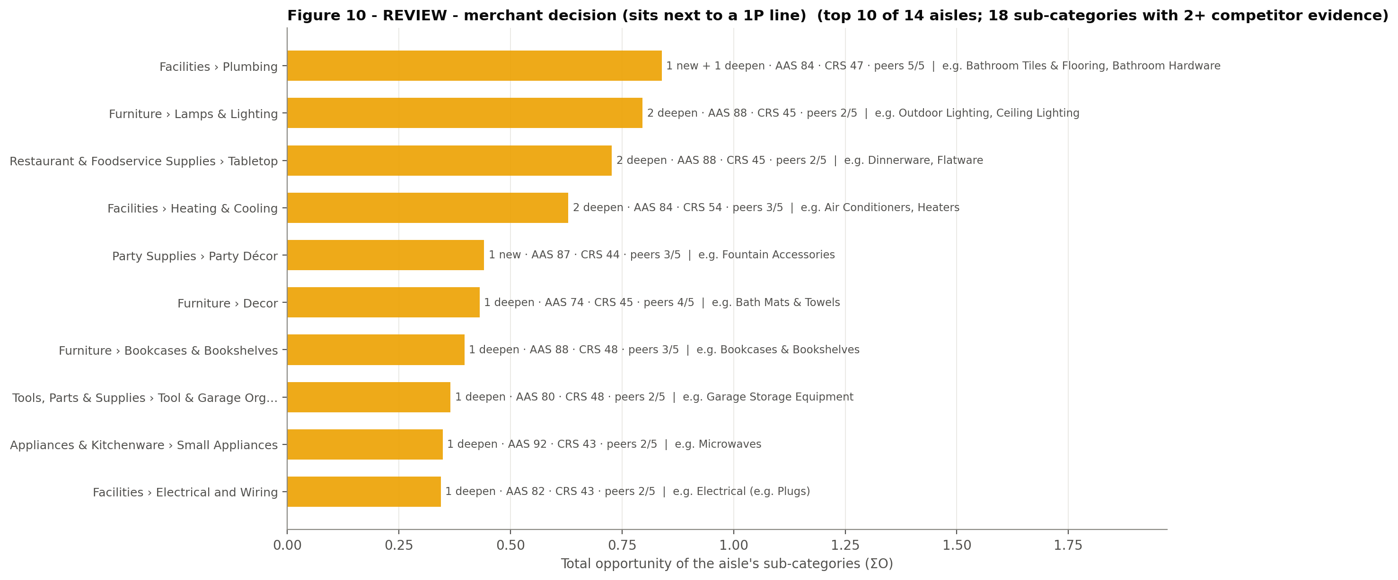
Figure 10 – REVIEW aisles ranked by total opportunity. Source: run_framework.py → figures/fig10_zone_review.png · sheet REVIEW
# | Staples aisle (L1 › L2) | Sub-categories to add or deepen (L2–L3) | Peers (best sub-category) | All competitors showing gaps in this aisle | AAS | CRS | ΣO | Grade
1 | Facilities › Plumbing | Bathroom Tiles & Flooring; Bathroom Hardware | 5/5 | Amazon, Office Depot, Walmart, Wayfair, West Elm | 84 | 47 | 0.84 | B
2 | Furniture › Lamps & Lighting | Outdoor Lighting; Ceiling Lighting | 2/5 | Amazon, Wayfair, West Elm | 88 | 45 | 0.80 | B
3 | Restaurant & Foodservice Supplies › Tabletop | Dinnerware; Flatware | 2/5 | Walmart, Wayfair, West Elm | 88 | 45 | 0.73 | B
4 | Facilities › Heating & Cooling | Air Conditioners; Heaters | 3/5 | Amazon, Office Depot, Walmart | 84 | 54 | 0.63 | A
5 | Party Supplies › Party Décor | Fountain Accessories | 3/5 | Amazon, Walmart, Wayfair | 87 | 44 | 0.44 | B
6 | Furniture › Decor | Bath Mats & Towels | 4/5 | Office Depot, Walmart, Wayfair, West Elm | 74 | 45 | 0.43 | A
7 | Furniture › Bookcases & Bookshelves | Bookcases & Bookshelves | 3/5 | Office Depot, Walmart, Wayfair | 88 | 48 | 0.40 | A
8 | Tools, Parts & Supplies › Tool & Garage Organization | Garage Storage Equipment | 2/5 | Walmart, Wayfair | 80 | 48 | 0.37 | B
9 | Appliances & Kitchenware › Small Appliances | Microwaves | 2/5 | Office Depot, Wayfair | 92 | 43 | 0.35 | B
10 | Facilities › Electrical and Wiring | Electrical (e.g. Plugs) | 2/5 | Amazon, Office Depot | 82 | 43 | 0.34 | B

What this means for Staples
- Lighting. Competitors are much deeper in ceiling and outdoor lighting (Ceiling Lighting: Staples 56 items; Wayfair 6.2x (13 shelves), West Elm 5.8x (257 items)). These shelves sit next to Staples' desk lamps and facilities lighting, which are 1P lines. The likely call is a curated décor-lighting assortment that stays clear of task and commercial lighting.
- Tabletop and bath textiles. Dinnerware (Staples 23 items; West Elm 4.8x (90 items), Wayfair 4.0x (8 shelves)), flatware, and bath mats and towels (Staples 3 items; West Elm 53.2x (176 items), Walmart 4.8x (22 shelves), Office Depot 4.2x (6 items)) overlap Staples' breakroom and foodservice lines. Split them: foodservice stays 1P, and home tabletop goes to the marketplace.
- Bathroom tiles and flooring is carried by all five competitors. With fountain accessories, it is one of the 2 new-category REVIEW items; it neighbours Staples' facilities plumbing and flooring lines.
- Heaters, air conditioners, bookcases, microwaves and TV stands are seasonal or bulky, sit next to 1P, and Office Depot is deeper in them. Decide on margin, not on the gap.

7. 1P-CORE GAP – fix in 1P, keep out of the marketplace
Decision: competitors are deeper in lines Staples considers core. Close the gap with 1P assortment and vendor programmes. A marketplace here would compete with Staples' own shelf.
22 aisles · 30 sub-categories · median AAS 89, median CRS 73

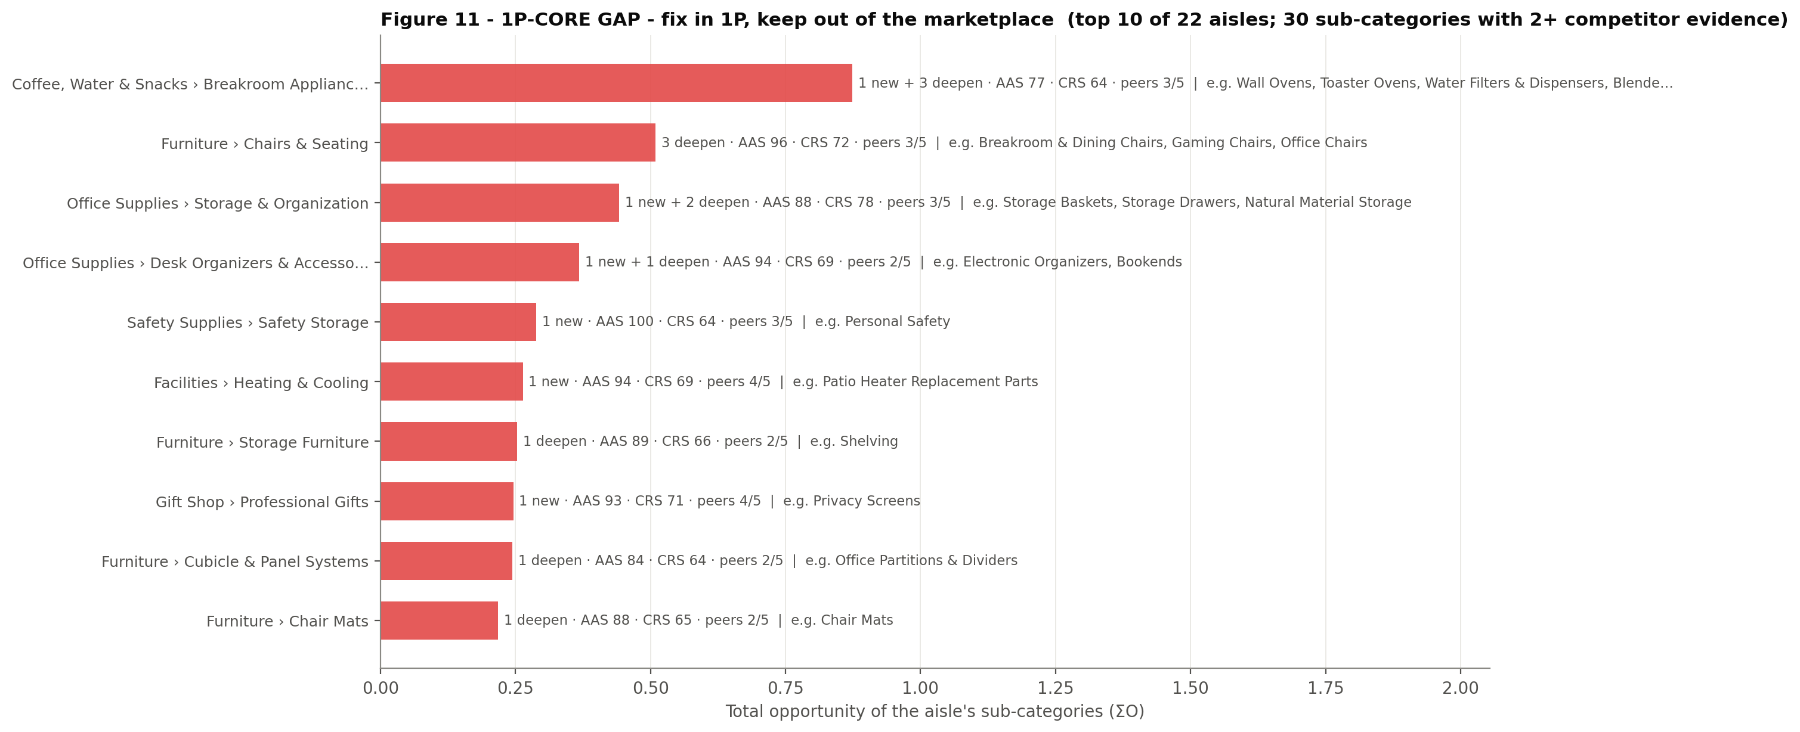
Figure 11 – 1P-CORE GAP aisles ranked by total opportunity. Source: run_framework.py → figures/fig11_zone_1pcore_gap.png · sheet 1PCORE_GAP
# | Staples aisle (L1 › L2) | Sub-categories to add or deepen (L2–L3) | Peers (best sub-category) | All competitors showing gaps in this aisle | AAS | CRS | ΣO | Grade
1 | Coffee, Water & Snacks › Breakroom Appliances | Wall Ovens; Toaster Ovens; Water Filters & Dispensers; Blenders & Food Processors | 3/5 | Amazon, Office Depot, Walmart, Wayfair | 77 | 64 | 0.87 | B
2 | Furniture › Chairs & Seating | Breakroom & Dining Chairs; Gaming Chairs; Office Chairs | 3/5 | Office Depot, Walmart, Wayfair, West Elm | 96 | 72 | 0.51 | A
3 | Office Supplies › Storage & Organization | Storage Baskets; Storage Drawers; Natural Material Storage | 3/5 | Amazon, Office Depot, Walmart, Wayfair | 88 | 78 | 0.44 | A
4 | Office Supplies › Desk Organizers & Accessories | Electronic Organizers; Bookends | 2/5 | Amazon, Office Depot, Walmart, West Elm | 94 | 69 | 0.37 | B
5 | Safety Supplies › Safety Storage | Personal Safety | 3/5 | Amazon, Office Depot, Walmart | 100 | 64 | 0.29 | B
6 | Facilities › Heating & Cooling | Patio Heater Replacement Parts | 4/5 | Amazon, Office Depot, Walmart, Wayfair | 94 | 69 | 0.26 | A
7 | Furniture › Storage Furniture | Shelving | 2/5 | Walmart, Wayfair | 89 | 66 | 0.25 | B
8 | Gift Shop › Professional Gifts | Privacy Screens | 4/5 | Amazon, Office Depot, Walmart, Wayfair | 93 | 71 | 0.25 | A
9 | Furniture › Cubicle & Panel Systems | Office Partitions & Dividers | 2/5 | Office Depot, Wayfair | 84 | 64 | 0.24 | B
10 | Furniture › Chair Mats | Chair Mats | 2/5 | Office Depot, Wayfair | 88 | 65 | 0.22 | B

What this means for Staples
- Seating and furniture core. Office Chairs: Staples 1,008 items; Wayfair 5.7x (12 shelves), Office Depot 5.7x (1,273 items), Walmart 2.3x (10 shelves). Also gaming chairs, breakroom and dining chairs, chair mats (Staples 308 items; Office Depot 5.0x (344 items), Wayfair 2.2x (4 shelves)), partitions, shelving and file cabinets. In these core lines competitors run deeper ranges – mostly Office Depot and Wayfair – and the fix is 1P range extension.
- Breakroom appliances – toaster ovens, blenders and food processors, water filters and dispensers. Office Depot is several times deeper (Blenders & Food Processors: Staples 65 items; Office Depot 7.2x (110 items), Wayfair 2.2x (4 shelves)).
- Office consumables – binders, notebooks, journals, markers, coffee and trash bags (Coffee: Staples 277 items; Office Depot 7.0x (434 items), Walmart 2.1x (9 shelves)). Depth gaps here are a 1P merchandising brief, not a marketplace one.

8. OFF-BRAND – real gaps, wrong store: pass
Decision: do not pursue these. Competitors sell them, but they sit far from Staples' customers and neighbourhood (AAS below 40). They would dilute the Staples brand.
16 competitor departments + 2 Staples aisles · 57 sub-categories seen at 2+ competitors (270 including single-competitor ones)

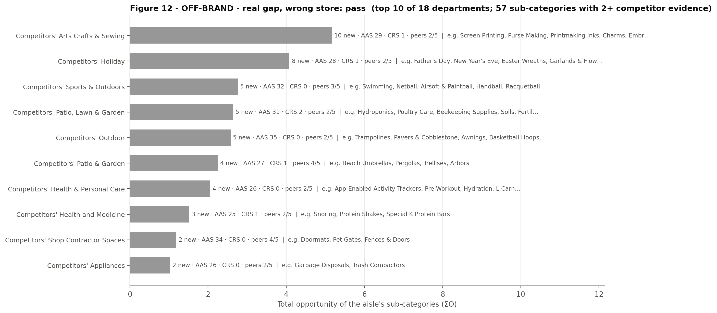
Figure 12 – OFF-BRAND sub-categories grouped by the competitor department they come from. Source: run_framework.py → figures/fig12_zone_offbrand.png · sheet OFFBRAND
# | Competitor department | Examples | Competitors | AAS | Sub-categories
1 | Competitors' Arts Crafts & Sewing | Screen Printing, Purse Making, Printmaking Inks, Charms, Embroidery | Amazon, Walmart | 29 | 10
2 | Competitors' Holiday | Father's Day, New Year's Eve, Easter Wreaths, Garlands & Flowers, Halloween Lights, Thanksgiving Decorations | Walmart, Wayfair | 28 | 8
3 | Competitors' Sports & Outdoors | Swimming, Netball, Airsoft & Paintball, Handball, Racquetball | Amazon, Walmart, Wayfair | 32 | 5
4 | Competitors' Patio, Lawn & Garden | Hydroponics, Poultry Care, Beekeeping Supplies, Soils, Fertilizers & Mulches, Livestock Supplies | Amazon, Walmart | 31 | 5
5 | Competitors' Outdoor | Trampolines, Pavers & Cobblestone, Awnings, Basketball Hoops, Carports | Walmart, Wayfair | 35 | 5
6 | Competitors' Patio & Garden | Beach Umbrellas, Pergolas, Trellises, Arbors | Amazon, Walmart, Wayfair, West Elm | 27 | 4
7 | Competitors' Health & Personal Care | App-Enabled Activity Trackers, Pre-Workout, Hydration, L-Carnitine | Amazon, Walmart | 26 | 4
8 | Competitors' Health and Medicine | Snoring, Protein Shakes, Special K Protein Bars | Amazon, Walmart | 25 | 3
9 | Competitors' Shop Contractor Spaces | Doormats, Pet Gates, Fences & Doors | Amazon, Walmart, Wayfair, West Elm | 34 | 2
10 | Competitors' Appliances | Garbage Disposals, Trash Compactors | Amazon, Walmart | 26 | 2

These are the categories we deliberately leave out, which matters as much as what we pick. The biggest clusters are craft niches (screen printing, purse making, embroidery), holiday-specific décor, individual sports (swimming, handball, airsoft), and farm and garden supplies (hydroponics, beekeeping, poultry care, soils).

9. VERIFY – already sold, but hard to find
Decision: before buying or opening any assortment here, check the Staples shelf listed below. Most of these are findability problems – naming and navigation – not assortment gaps.
22 Staples aisles · 31 sub-categories seen at 2+ competitors · 121 of 219 checked "gaps" were already on Staples.com

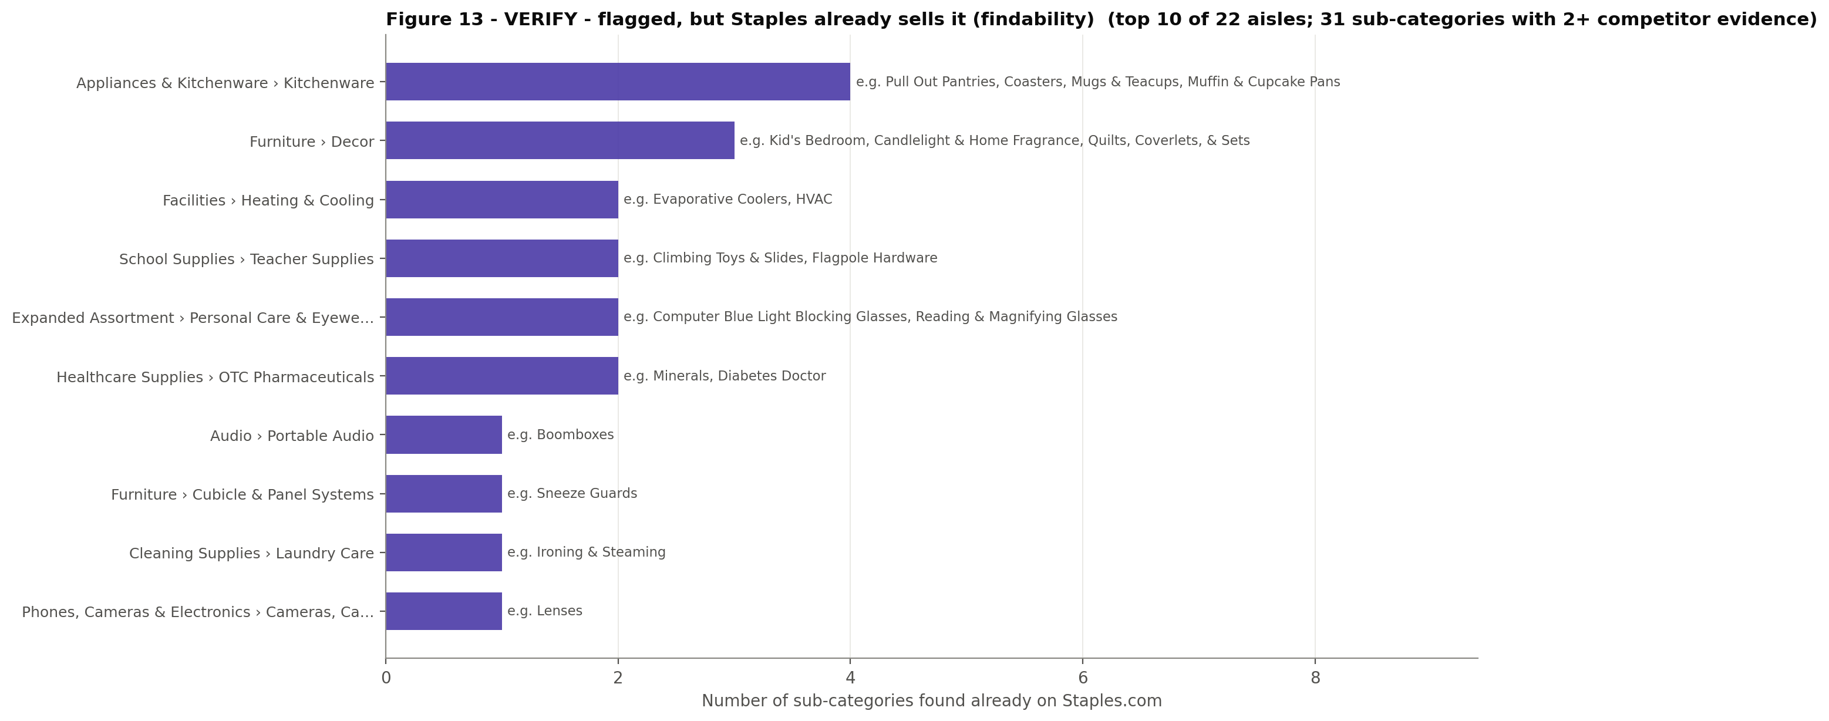
Figure 13 – VERIFY: Staples aisles where categories the models first flagged as missing were found. Source: run_framework.py → figures/fig13_zone_verify.png · sheets VERIFY, Verification_Log
Category flagged as missing | Seen at | Where it already lives on Staples.com (or status)
Kid's Bedroom | 5/5 | Furniture › Decor › Beds & Bedding
Candlelight & Home Fragrance | 3/5 | Furniture › Decor › Candles
Evaporative Coolers | 3/5 | Facilities › Heating & Cooling › Air Conditioners
HVAC | 3/5 | Facilities › Heating & Cooling
Quilts, Coverlets, & Sets | 4/5 | Furniture › Decor › Beds & Bedding › Bedding
Boomboxes | 3/5 | Audio › Portable Audio › Portable Speakers & Radios
Sneeze Guards | 3/5 | Furniture › Cubicle & Panel Systems › Desktop Privacy Panels
Ironing & Steaming | 2/5 | Cleaning Supplies › Laundry Care › Laundry Room Organization › Laundry Accessories
Lenses | 3/5 | Phones, Cameras & Electronics › Cameras, Camcorders & Accessories › Camera & Camcorder Accessories
Pull Out Pantries | 2/5 | Appliances & Kitchenware › Kitchenware › Kitchen Accessories › Kitchen Storage & Organization
Substance Analysis Instrumentation | 2/5 | Laboratory & Scientific Supplies › PH & Electrochemistry
Sweepers | 2/5 | Cleaning Supplies › Floor & Carpet Cleaning Equipment › Vacuums

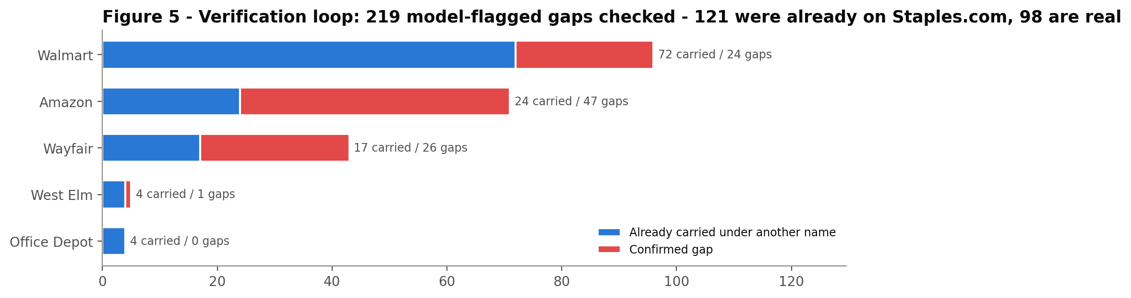
Figure 5 – The verification check: of the model-flagged gaps we checked, most were already on Staples.com. Source: run_framework.py → figures/fig05_verification_loop.png · sheet Verification_Log
- Findability quick wins. Rename or cross-list "Compasses", the shelf that holds patio furniture. Surface candles and home fragrance, evaporative coolers, pull-out pantries, quilts and coverlets, and sneeze guards (sold as "Desktop Privacy Panels") under the words customers use.
- Health and personal-care pages – mostly Walmart brand pages, kept in the watch list – map onto Staples' OTC and personal-care shelves. Staples carries these product types, but the shelves are thin: Ear Drops & Eye Drops has 4 items.

10. The L1 view: strategic themes
Grouping the aisles into themes gives the L1 story. The themes group Staples departments, and some shelves are placed by keyword because Staples files a few lifestyle shelves in unexpected places.
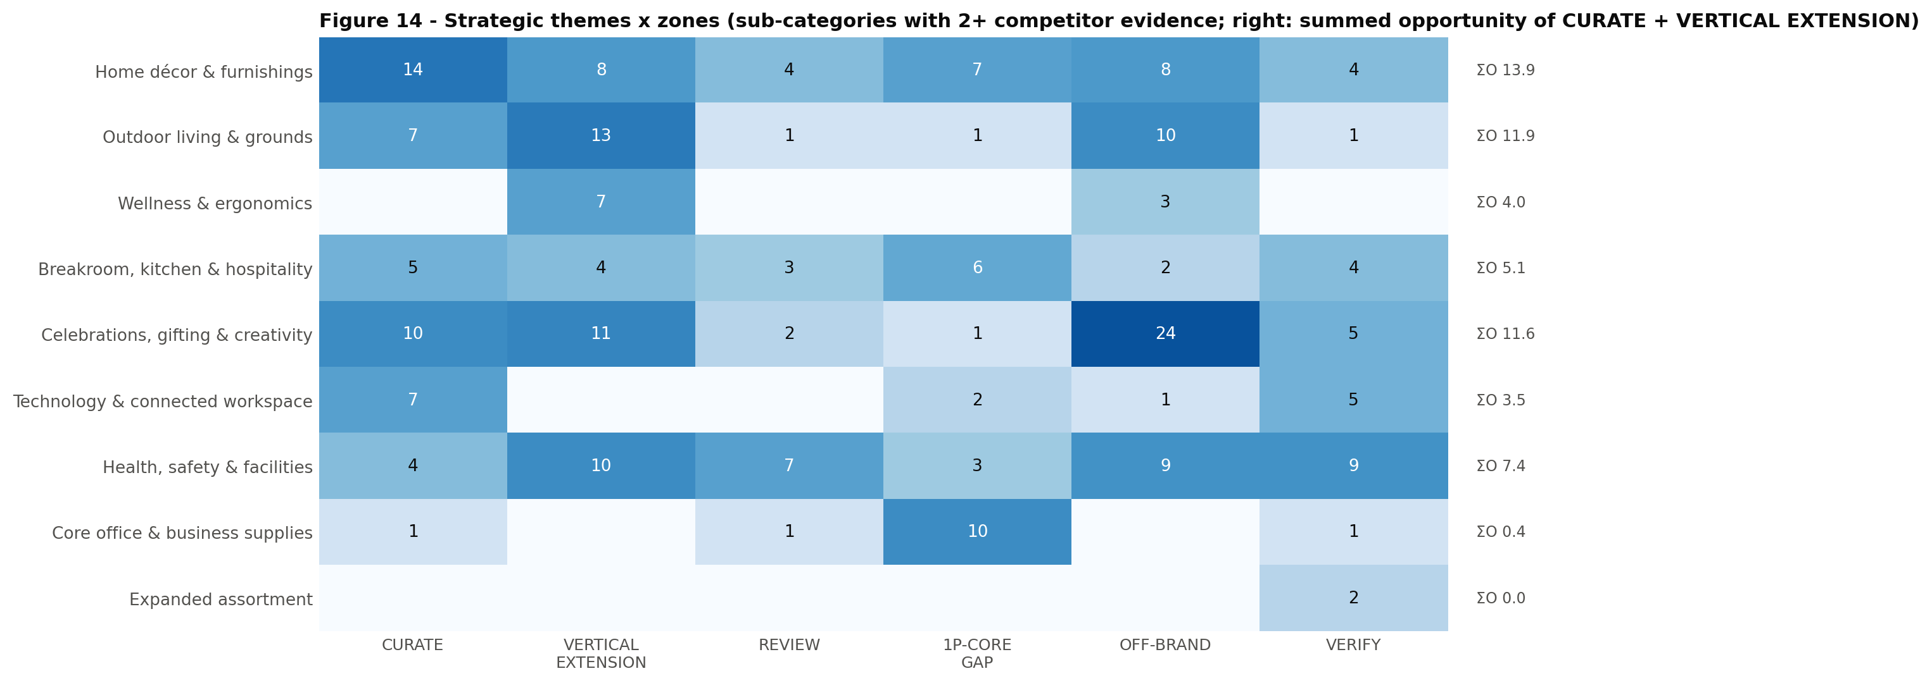
Figure 14 – Strategic themes × zones (sub-categories with 2+ competitor evidence). Source: run_framework.py → figures/fig14_themes.png · sheet Themes
Theme | CURATE | VERTICAL EXT. | REVIEW | 1P-CORE GAP | OFF-BRAND | VERIFY | ΣO (CURATE + VE)
Home décor & furnishings | 14 | 8 | 4 | 7 | 8 | 4 | 13.9
Outdoor living & grounds | 7 | 13 | 1 | 1 | 10 | 1 | 11.9
Wellness & ergonomics | 0 | 7 | 0 | 0 | 3 | 0 | 4.0
Breakroom, kitchen & hospitality | 5 | 4 | 3 | 6 | 2 | 4 | 5.1
Celebrations, gifting & creativity | 10 | 11 | 2 | 1 | 24 | 5 | 11.6
Technology & connected workspace | 7 | 0 | 0 | 2 | 1 | 5 | 3.5
Health, safety & facilities | 4 | 10 | 7 | 3 | 9 | 9 | 7.4
Core office & business supplies | 1 | 0 | 1 | 10 | 0 | 1 | 0.4
Expanded assortment | 0 | 0 | 0 | 0 | 0 | 2 | 0.0

- Home décor & furnishings leads on both counts: 14 CURATE sub-categories and ΣO 13.9. It is led by Furniture › Décor – bedding, bath, candles, vanities, daybeds – with bedroom furniture, tables and sofas behind it. This is the "white chair" logic: lifestyle furnishings for the same customer who buys the home-office chair.
- Celebrations, gifting & creativity (ΣO 11.6) is led by sewing and quilting in CURATE and party décor in VERTICAL EXTENSION. Most of its OFF-BRAND volume is holiday-specific and craft-niche.
- Outdoor living & grounds (ΣO 11.9): planters, hedge trimmers, chimineas and the patio shelf in CURATE; greenhouses, gazebos and garden equipment behind them in VERTICAL EXTENSION.
- Core office & business supplies: 10 of its 13 sub-categories are 1P-CORE GAP – as it should be.

11. How the recommendations connect to Staples' assortment
Two views from the two analytical engines show the same thing from different angles. The graph view (Figure 17) follows each recommendation through the knowledge graph to the Staples aisle and department it plugs into. The vector view (Figure 16) maps the whole category space. Visually, CURATE and VERTICAL EXTENSION sit next to Staples' furniture, décor and kitchen clusters, while much of OFF-BRAND sits in separate clusters.
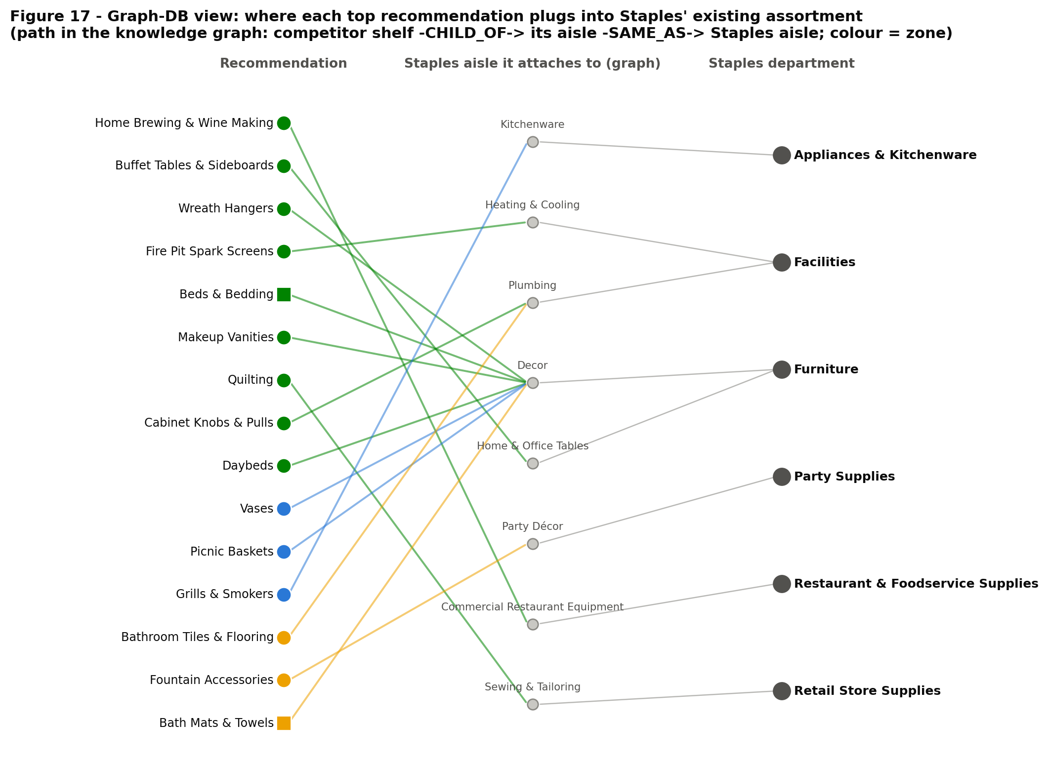
Figure 17 – Graph-DB view: where each top recommendation plugs into Staples' existing aisles and departments. Source: method_g_graph.py + run_framework.py → figures/fig17_graph_dock.png

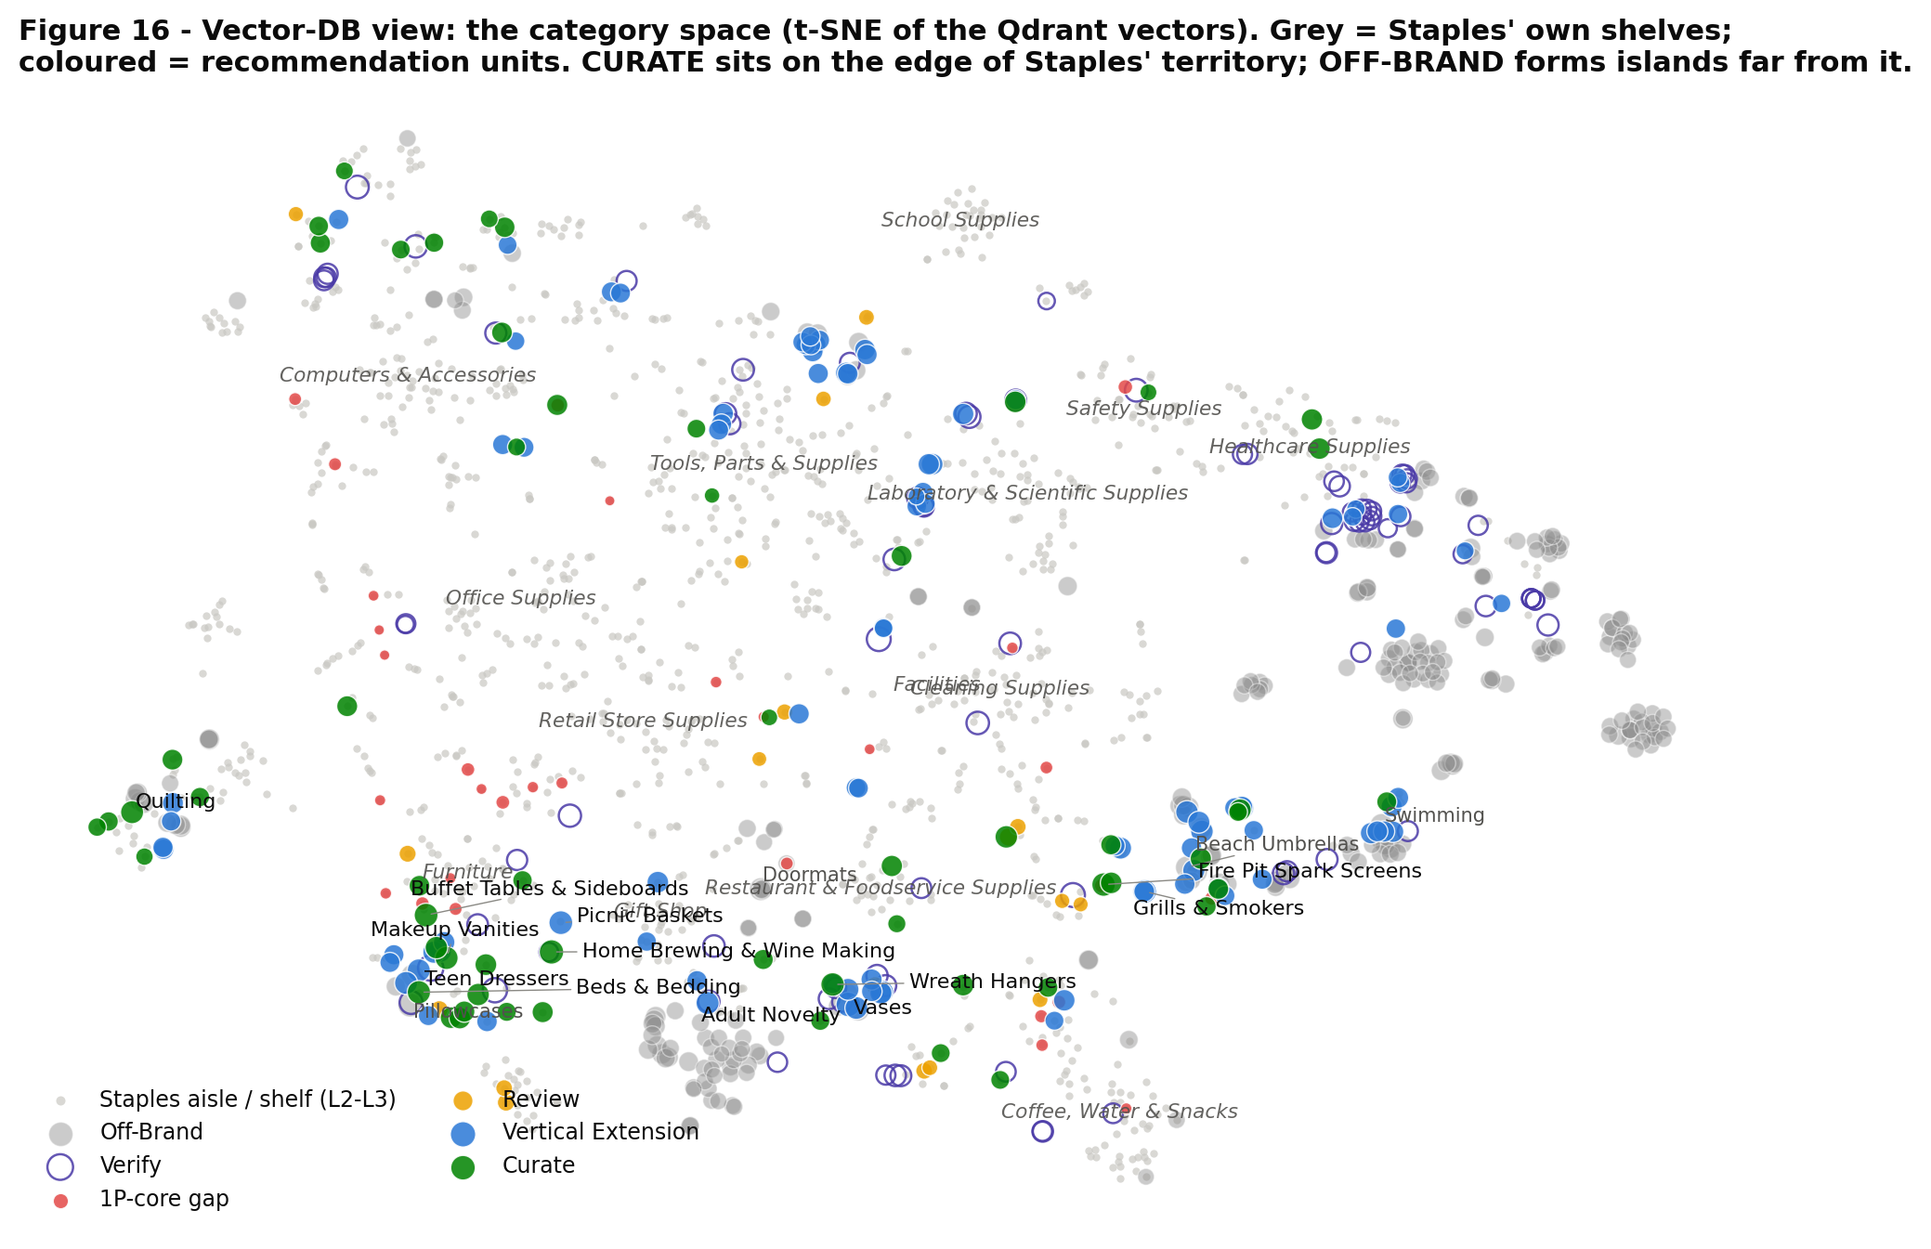
Figure 16 – Vector-DB view: the category space (t-SNE of the Qdrant vectors). Grey = Staples' shelves; colour = recommendation zone. Source: method_v_vector.py + run_framework.py → figures/fig16_vector_map.png

12. How much to trust this, and what it does not yet include
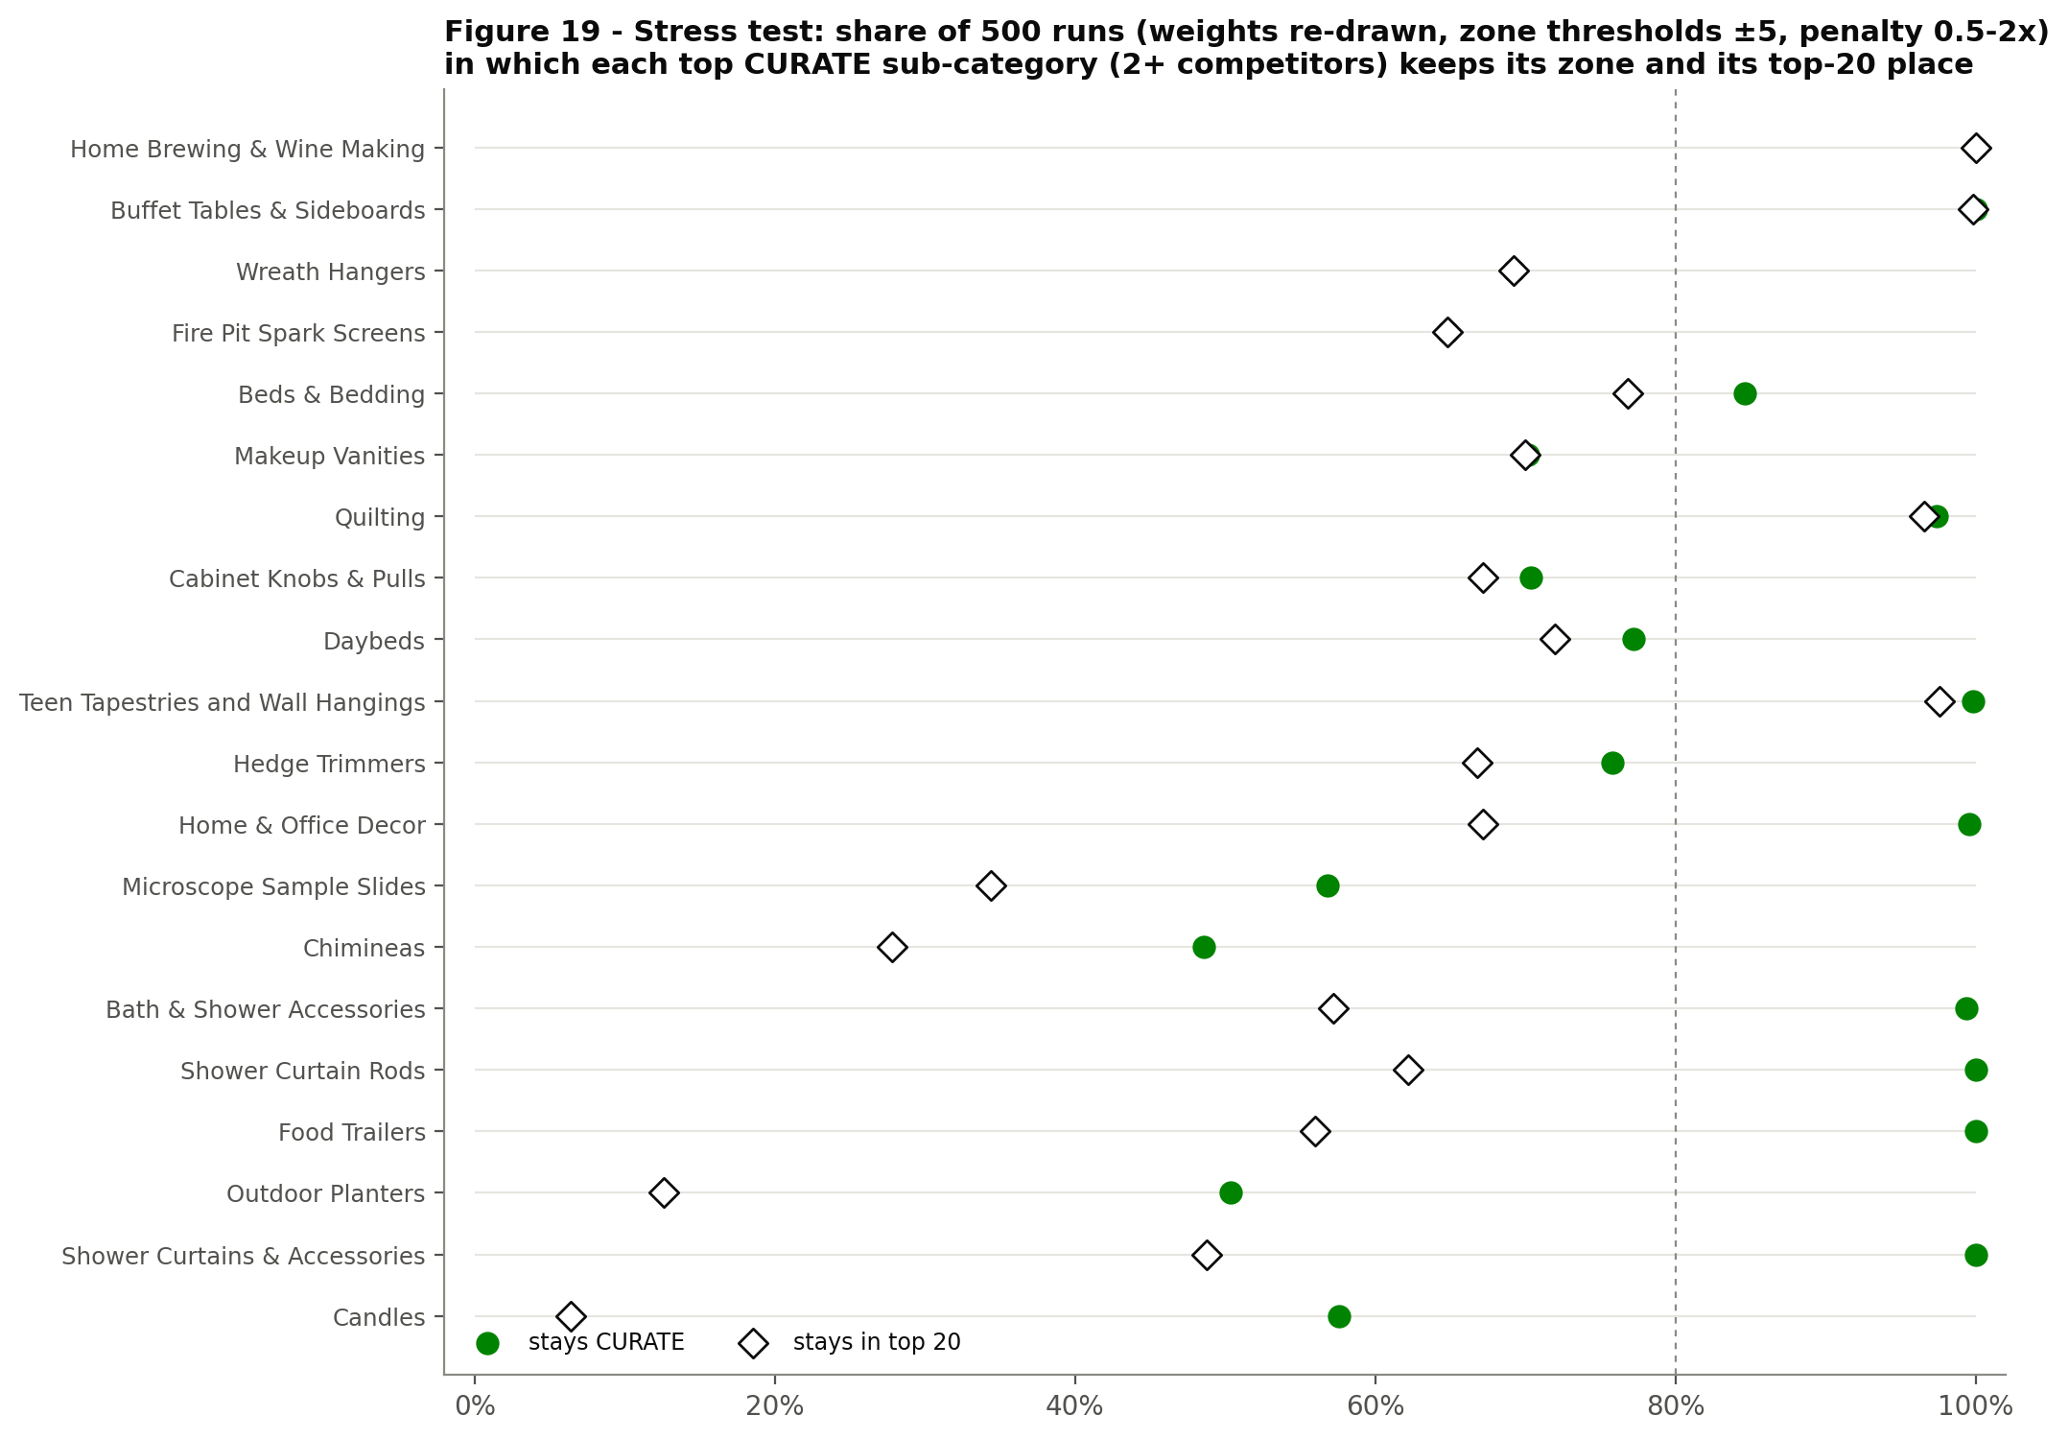
Figure 19 – Stress test: share of 500 re-weighted runs in which each top CURATE sub-category keeps its zone and its top-20 place. Source: run_framework.py → figures/fig19_sensitivity.png · sheet All_Units (p_approved, p_top_n)
- Zones are robust; the order inside a zone is indicative. 10 of the top 20 CURATE sub-categories stay CURATE in 80% or more of runs, while only 4 hold a fixed top-20 place. Many opportunities score close together.
- Every flagged gap behind an actionable call was checked. 103 of 103 competitor shelves behind the consensus ENTER recommendations are verified labels; in total 219 flagged gaps were checked and 121 turned out to be already sold.
- Two independent methods. The vector and graph engines agree on the zone for 44% of new-category sub-categories. Their adjacency scores correlate at ρ = 0.40. Where they disagree, the average places the unit, and the evidence grade drops to B or C (Figure 20 in the methodology document).
- Matching quality. The vector method picks the right Staples shelf first time for 84% of Office Depot shelves and 70% of West Elm's. It does so for 55%–59% of Wayfair, Amazon and Walmart shelves, whose vocabularies are further from Staples'. That is why flagged gaps go through verification before they are recommended.
- Not yet included: Staples sales and margin data. The "coreness" behind CRS is an explicit, editable assumption; replacing it with Staples' category sales bands is the single biggest upgrade. Demand signals such as search volume and social trends are not included either; the code accepts them as an optional input. Finally, the labelled checks were made by the analysis team with Claude and still need merchant confirmation.

13. Recommended next steps
- Merchant session (2 hours): walk the CURATE and REVIEW tables with the category merchants. Confirm or override each zone and record the verdict in the workbook – the code reads it back as labels.
- Replace the coreness assumption with sales bands: one data pull of 1P revenue and margin by L2 aisle turns CRS from an assumption into a measurement.
- Add demand: search volume for the top 40 sub-categories, from keyword tools and on-site search, feeds the optional demand term in O.
- Run the archetype PoC on the top CURATE aisles: Furniture › Décor (bedding, bath, candles), Sewing & Tailoring, and Grounds Maintenance and outdoor living. Compare SKUs and attributes to decide what a curated seller assortment looks like.
- Ship the findability fixes now: rename the "Compasses" shelf, cross-list the VERIFY items under the words competitors use, and add them to on-site search synonyms. These need no new assortment.
- Re-run quarterly: the pipeline re-runs end to end on fresh navigation trees (about 6 minutes). A new competitor is one adapter entry plus about 120 labelled rows.

Appendix – figure and table index
Every figure is written by the Python code to outputs/final/figures/. Every table in this document is a view of outputs/final/Category_Recommendations_v2.xlsx.
Figure | What it shows | Produced by | Workbook sheet
1 | Competitor panel and data availability | run_framework.py (framework_outputs.fig01_data) | Data_Audit
4 | How much of each competitor Staples covers | fig04_coverage | Node_Ensemble, Calibration
5 | Verification check | fig05_verification | Verification_Log
6 | Decision matrix at aisle level (L2) | fig06_family_matrix | Aisle_Recommendations
7 | Decision matrix at sub-category level (in methodology) | fig07_unit_matrix | All_Units
8–13 | One chart per zone | fig_zone | CURATE … VERIFY
14 | Strategic themes × zones | fig14_themes | Themes
15 | Peer evidence behind top picks | fig15_peers | Concept_Members, Deepen_Evidence
16 | Vector-DB map of the category space | fig16_vector_map (Qdrant vectors) | –
17 | Graph-DB view: where recommendations dock | fig17_graph (knowledge graph) | Aisle_Recommendations
18 | DEEPEN evidence by competitor | fig18_deepen | Deepen_Evidence
19 | Stress test (500 runs) | fig19_sensitivity | All_Units

